**REQUISITION PORTAL**

**Project Objective:** The organization want to “go paperless” and fast track the procurement process. In so doing, we want an enterprise resource system that can cater for all aspect of our operations

**Project Scope:** To develop a full fledge requisition system that will have all aspect of making requisition, approvals, procurement process, Payment and Logistics. The portal can be integrated with other organizations portal.

**Project Timeline:** 6 Weeks

**Task:**

1. System design and Data Impact assessment
2. Defining parameter and scope
3. Users Registration
4. Dashboards and designs
5. Forms
6. Logic flow
7. Testing
8. Deployment to Live environment
9. Final testing and clearing of bugs
10. Presentation
11. LIVE

**Milestone**

|  |  |  |  |  |  |  |  |
| --- | --- | --- | --- | --- | --- | --- | --- |
| **TASK** | **1** | **2** | **3** | **4** | **5** | **6** | **RESPONSIBILTY** |
| **System design and Data Impact assessment** |  |  |  |  |  |  | Kenny, Abayomi, Yosola |
| **Defining parameter** |  | **1** |  |  |  |  | Kenny, Yosola and Abayomi |
| **Registration Process** |  |  | **2** |  |  |  | Yosola |
| **Dashboards and designs** |  |  |  | **3** |  |  | Yosola |
| **Forms** |  |  |  |  |  |  | Yosola |
| **Logic flow** |  |  |  | **4** |  |  | Yosola |
| **Testing** |  |  |  |  |  |  | Yosola, Kenny |
| **Deployment to Live environment** |  |  |  |  |  |  | Yosola, Kenny |
| **Final testing and clearing of bugs** |  |  |  |  | **5** |  | Yosola, Kenny |
| **Presentation** |  |  |  |  |  |  | Kenny |
| **LIVE** |  |  |  |  |  |  | Kenny, Abayomi |

1. **Defining parameter and scope**

Requisitions are done based on approval levels across all locations. All requests from other locations (including the HQ) are processed from the HQ. This is done base on reporting line base on the reporting

* 1. **DESIGNATION/ POSITIONS**

1. Officers
2. Site Heads and Team Leads
3. Managers
4. CLevel
5. CEO/MD/Owner

* Officers – By default all designations are Users.
* Site Head – these are the head of all the locations.
* Team Lead – are the head of units in the Head office.
* Manager – These are mid managers and the oversee some core operations
* CLevel – These are the Management Team
  1. **LOCATIONS – (We should be able to self-create locations)**

HQ, LUTH, VI LAB, MCC LAB, LEKKI LAB, GWARINPA LAB, PH LAB, ENUGU LAB, ISOS LAB, IKEJA BCP, ILUPEJU BCP, FESTAC BCP, IKOTUN BCP, SAGAMU BCP, ABEOKUTA BCP, IFE BCP, ILORIN BCP, PH BCP, WARRI BCP, BENIN BCP, GWAGWALADA BCP, KADUNA BCP, ASOKORO BCP, WUSE BCP

* 1. **UNITS - – (We should be able to self-create Units)**

1. Laboratory
2. Phlebotomy
3. Pathology
4. Login
5. ICT
6. Engineering
7. Quality Assurance
8. Finance
9. Marketing
10. Human resource
11. Admin and Logistics
12. Store
13. Procurement
14. Helpdesk
15. Legal
16. Management
    1. **REQUISITION CATEGORIES**
17. Consumables – these are store items
18. Assets –
19. Services and Maintenance
20. HR
21. Other/ Non Assets
    1. **REPORTING FLOW**

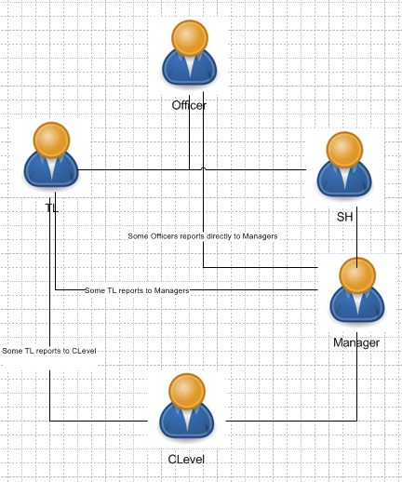

1. **REGISTRATION**

**Registration Fields**

Name:

Location: (dropdown location)

Designation: (dropdown position)

Unit: (dropdown unit)

Email:

Reporting designation: (dropdown SH, TL, MGR, CL)

Reporting Line: (dropdown subs for above)

Reporting 2: optional

* 1. **Registration of an officer**

Name: Ngozi

Location: LUTH

Designation: Officer/User

Unit: Phlebotomy

Email:

Reporting designation: SH (drop down SH, TL, Mgr, Clevel)

Reporting Line: SH LUTH

Reporting 2: optional

* 1. **registration for CLevel**

Name:

Location:

Designation: CLevel

Unit:

Email:

Reporting designation: Owner/Admin/CEO

Reporting Line:

Reporting Line 2:

1. **DASHBOARD**

The under listed Designations will have a dashboard

1. Officers/Users
2. Approval – SH,TL,Manager
3. Procurement
4. Internal Control
5. Finance
6. Treasury
7. Admin
8. ………………
9. **Requisition Flow**

1. CONSUMABLE

USER(LUTH) - SH LUTH - Manager (Area ops Lag1) - IC – Store. This depends on the Reporting line.

2. ASSET

User(LUTH) - SH LUTH - Manager (area ops Lag1) - Clevel (National lab) - (by default it should go to the UNIT or we make them choose the Units in HQ) UNIT (Admin) - Clevel (of the Unit) – Procure

So Requisition

**1. CONSUMABLES**

USER(LUTH) - SH LUTH - Manager (Area ops Lag1) - IC - Store

**2. ASSET**

User(LUTH) - SH LUTH - Manager (area ops Lag1) - Clevel (National lab) - (by default it should go to the UNIT or we make them choose the Units in HQ) UNIT ( say Admin) - Clevel (of the Unit) - Procurement (attaches PO, quotes, and fills form) - IC ( approves, download files and directs to) - Finance (DFM/CFO). After approval, it goes to Procurement (in approved PO table) (Procurement fills the Payment memo form)- IC - CFO - Treasury.

User(ICT) - TL(ICT) - Clevel (of the Unit) - Procurement (attaches PO, quotes, and fills form) - IC ( approves, download files and directs to) - Finance (DFM/CFO). After approval, it goes to Procurement (in approved PO table) (Procurement fills the ...)

**3. SERVICES/MAINTENANCE**

User(LUTH) - SH LUTH - Manager (area ops Lag1) - Clevel (National lab) - (by default it should go to the UNIT or we make them choose the Units in HQ) UNIT ( say Admin) - Clevel (of the Unit) - Procurement (attaches PO, quotes, and fills form) - IC ( approves, download files and directs to) - Finance (DFM/CFO). After approval, it goes to Procurement (in approved PO table) (Procurement fills the Payment memo form)- IC - CFO - Treasury.

Also, can the names of requestor and the approvals with time and date stamp appear on the final print out (maybe below the paper

